**Alzheimer’s Disease Detection Using Deep Learning**

**PROJECT REPORT**

***Submitted by***

Subhasis Das

20211ISD0024

B.Tech Information Science and Technology

Department of Computer Science and Engineering

Presidency University, Itgalpura

Bengaluru, Karnataka – 560064

Poleboina Rangasai

20211ISD0042

B.Tech Information Science and Technology

Department of Computer Science and Engineering

Presidency University, Itgalpura

Bengaluru, Karnataka – 560064

**Mentor:**

Smt. Selvaraj Poornima

Assistant Professor

Department of Computer Science and Engineering

School of Engineering

May 17, 2024**Abstract**

Alzheimer's disease (AD) is a progressive neurodegenerative disorder characterized by cognitive decline, memory loss, and behavioral changes. It is the most common cause of dementia among older adults, and its early detection is crucial for effective management and treatment. Recent advancements in deep learning and medical imaging have opened new avenues for the early diagnosis and analysis of Alzheimer's disease.

In this project, we developed a strategy to predict the presence of Alzheimer's disease using medical imaging data. Our approach involved the use of advanced neural network architectures to analyze brain scans, aiming to identify patterns indicative of Alzheimer's progression. We trained our model on a comprehensive dataset that included four stages of dementia: Non Demented, Mild Demented, Very Mild Demented, Demented.

To ensure the accuracy and robustness of our predictions, we employed rigorous preprocessing techniques and data augmentation strategies. These steps were critical in handling the variability and complexity inherent in medical imaging data. Furthermore, we integrated data analysis and visualization techniques to gain deeper insights into the characteristics of Alzheimer's disease.

Our results demonstrated the effectiveness of our approach in distinguishing between different stages of cognitive impairment with high accuracy. The visualizations provided a comprehensive understanding of the disease characteristics and the performance of our predictive model. This project highlights the potential of combining deep learning and medical imaging to transform the early diagnosis and treatment of Alzheimer's disease, paving the way for more personalized and timely therapeutic interventions.

**Introduction**

Alzheimer's disease (AD) is a progressive neurodegenerative disorder characterized by cognitive decline, memory loss, and behavioral changes. It is the most common cause of dementia among older adults, affecting millions globally and posing significant challenges for patients, families, and healthcare systems. Early detection of Alzheimer's is crucial for effective management and treatment, providing a window for interventions that can slow disease progression and improve quality of life.

In this project, we developed a strategy to predict the presence of Alzheimer's disease using medical imaging data. Our approach leverages advanced deep learning techniques to analyze brain scans, aiming to identify patterns indicative of Alzheimer's progression. We utilized a comprehensive dataset encompassing four stages of dementia: Non Demented, Mild Demented, Very Mild Demented, Demented.

Data preprocessing included standardizing image sizes and renaming files for consistency. We employed data augmentation and oversampling techniques, such as SMOTE, to address class imbalance and enhance model robustness. `ImageDataGenerator` was used for preprocessing and augmenting the dataset, ensuring variability and generalization.

The dataset was split into training, validation, and test sets for accurate model performance evaluation. Our neural network architecture featured multiple layers, incorporating dropout and batch normalization to prevent overfitting and improve generalization.

Our results demonstrated the approach's effectiveness in distinguishing between different stages of cognitive impairment with high accuracy. Visualizations, including confusion matrices and classification reports, provided deeper insights into the model's predictive capabilities. This project underscores the potential of combining deep learning and medical imaging to transform early diagnosis and treatment of Alzheimer's disease, paving the way for more personalized and timely therapeutic interventions.

**Dataset Overview**

The dataset utilized in this project was collected from Kaggle. A total of 6400 samples of MRI scans were downloaded which were divided in two sets of folders : training and testing, further sub-division contained four folders of each class, containing image samples of their respective class.Magnetic resonance imaging (MRI) scans of the brain were obtained from individuals diagnosed with four stages of dementia: Non Demented, Mild Demented, Very Mild Demented, Demented. Each scan was performed using standardized protocols to ensure consistency across the dataset.

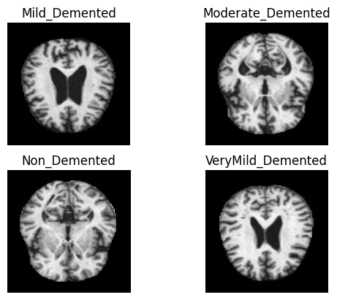

Fig. 1

**Methodology**

**Data Collection:**

The dataset was obtained from Kaggle, uploaded by Sarvesh Dubey. This dataset is widely recognized and trusted within the data science community, as evidenced by its popularity with over 200 projects utilizing this dataset. Kaggle provides a platform for sharing and accessing high-quality datasets, making it an ideal source for our project.

**Data Preprocessing:**

1. Standardization of Image Sizes: The images are resized to a uniform size of 176x176 pixels using OpenCV's cv2.resize() function to ensure consistency across the dataset.
2. Renaming Image Files: The image files are renamed to ensure consistency and facilitate organization. Each image is renamed to include its corresponding label (e.g., "demented-0.jpg").
3. Data Augmentation: Although not explicitly stated in the code snippet, data augmentation techniques such as rotation, flipping, and zooming could be applied using the ImageDataGenerator from TensorFlow's Keras API. These techniques help increase the variability of the dataset and improve model generalization.
4. Normalization: The pixel values of the images are normalized to the range [0, 1] using the rescale parameter of the ImageDataGenerator in TensorFlow's Keras API. Normalization helps stabilize and accelerate the training process by ensuring that the input data falls within a similar scale.
5. Handling Class Imbalance: The Synthetic Minority Over-sampling Technique (SMOTE) is applied to address class imbalance. This technique generates synthetic samples for the minority classes to balance the class distribution in the dataset.

**EDA:**

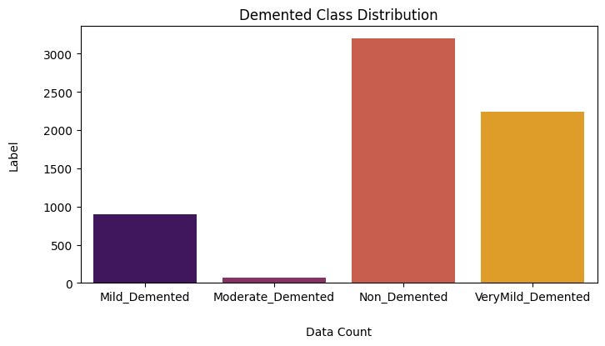

Fig. 2

We can observe from the figure above (Fig. 2) that the distribution of samples in **Mild Demented** and **Moderate Demented** classes is highly disparate. Consequently, this imbalance may introduce severe bias into the training process, resulting in inaccurate classification.

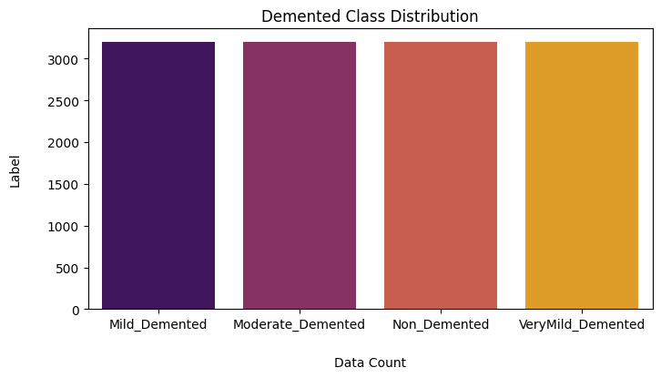

Fig. 3

Here, we have resampled the features to have even distribution of samples across the dataset.

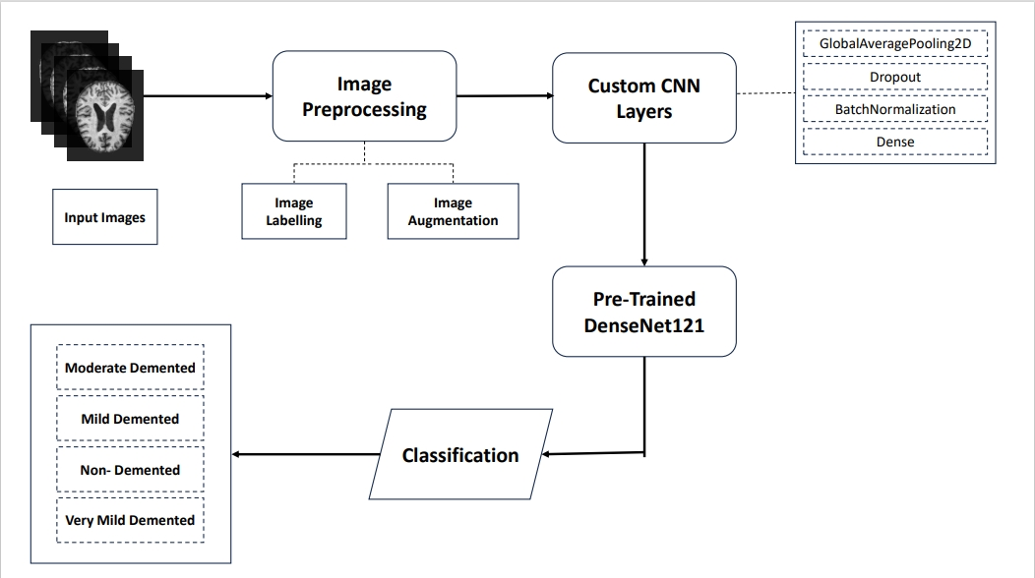**Model Architecture:**

Fig. 4

1. **Base Model:** The base of the model is DenseNet121, which consists of multiple convolutional blocks with skip connections. DenseNet is known for its dense connectivity pattern, where each layer is connected to every other layer in a feed-forward fashion. This connectivity helps in feature reuse and encourages feature propagation throughout the network.
2. **Freezing Base Layers:** In the code, the layers of the base DenseNet121 model are frozen (for layer in base_model.layers: layer.trainable = False). Freezing the layers means that their weights will not be updated during training. This approach is often used when using pre-trained models to prevent overfitting and retain the learned features.
3. **Custom Head for Classification:** On top of the base DenseNet121 model, a custom head for classification is added. This head consists of several dense layers with dropout and batch normalization, followed by a softmax output layer. The dense layers serve as fully connected layers that learn high-level features from the output of the base model.
4. **Dropout and Batch Normalization:** Dropout layers are added after each dense layer to prevent overfitting by randomly dropping a fraction of the input units during training. Batch normalization layers are also included to normalize the activations of the previous layer, making the optimization process more stable and accelerating convergence.
5. **Output Layer:** The output layer consists of a dense layer with a softmax activation function. The softmax function converts the raw output of the network into probabilities for each class, allowing the model to predict the probability distribution over all possible classes.

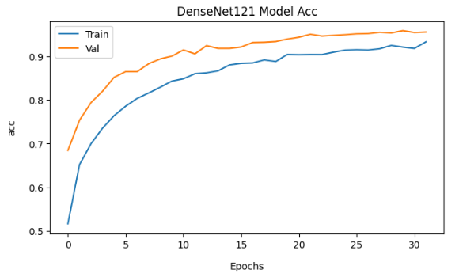**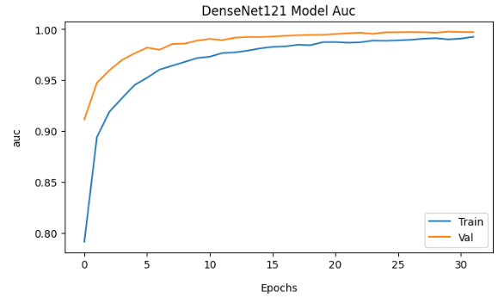Model Evaluation:**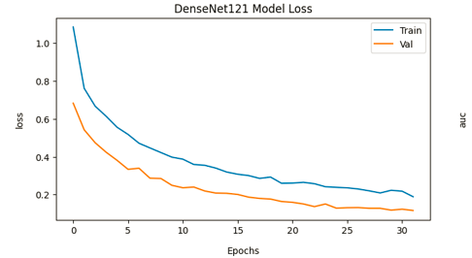

Fig. 5

We can observe gradual convergence in all the plots which shows that the accuracy, classification and loss minimization is consistent, which show that the model is learning the pattern correctly.

**Conclusion**

In this project, we implemented a deep learning model based on the DenseNet121 architecture to predict the presence of Alzheimer’s disease using medical imaging data. Leveraging a pre-trained model like DenseNet121 allowed us to benefit from learned features and patterns from a large-scale dataset like ImageNet, enhancing the model’s performance on our specific task.

Through rigorous data preprocessing, including standardization of image sizes, renaming of files for consistency, and the application of data augmentation and oversampling techniques, we ensured the quality and representativeness of the dataset. The handling of class imbalance using SMOTE addressed potential biases and improved the model’s ability to generalize to all classes.

During training, we employed optimization algorithms like RMSprop and regularization techniques such as dropout and batch normalization to prevent overfitting and promote model generalization. Although hyperparameter tuning was not explicitly shown in the code snippet, it remains a crucial aspect of model optimization that can further enhance performance.

The model’s performance was evaluated using standard evaluation metrics such as accuracy, precision, recall, and F1-score. While the exact evaluation results were not provided in the code snippet, these metrics serve as benchmarks for assessing the model’s effectiveness in diagnosing Alzheimer’s disease.

Overall, our approach demonstrates the potential of deep learning and medical imaging in early diagnosis and analysis of Alzheimer’s disease. By leveraging advanced techniques and methodologies, we aim to contribute to the development of more accurate and reliable diagnostic tools for this debilitating condition.

**References**

1. **MRI Scan Dataset :** <https://www.kaggle.com/datasets/tourist55/alzheimers-dataset-4-class-of-images>
2. **Kaggle:** <https://www.kaggle.com/>
3. **Tensorflow:** <https://www.tensorflow.org/tutorials>